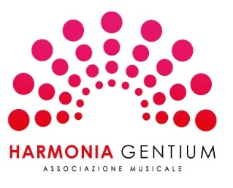

The King’s Singers

PROGRAMMA CONCERTO A LECCO DEL 2 DICEMBRE 2019

Arr. di Jim Clements, The Angels Gabriel
G.P.luigi da Palestrinas: Ave Regina Caelorum
W. Byrd: Ave Verum Corpus,
Da Palestrina: Alma Redemptoris Mater,
Hector Berlioz: Audieu des Bergers
Francis Poulenc: Quem Vidistis pastores, dicite
Bob Chilcott: The Shepherd's Carol
Herbert Howells: Here is the little door
Peter Warlock: Bethlehem Down
Herbert Howells: A spotless rose
Pyotr Ilyich Thaikovsky,
arr. Jeremy Lubbock: The crown of roses
Herbert Howells: Sing lullaby
Canto tradizionale
arr Alexander L'Estrange: Still, still, still

